**Practical 1**

**Creating Forensic Images FTK**

Imager allows you to write an image file to a single destination or to simultaneously write multiple image files to multiple destinations.

To create a forensic image:

1. Click File, and then Create Disk Image, or click the button on the tool bar.

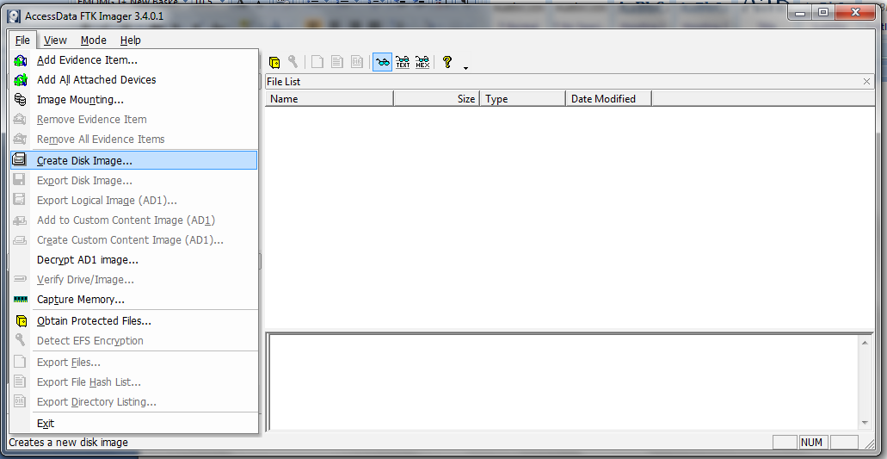

1. Select the source you want to make an image of and click Next.

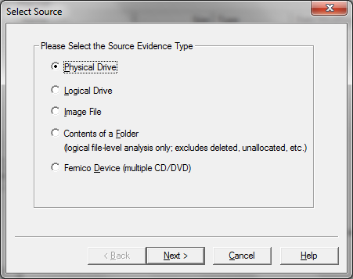

If you select Logical Drive to select a floppy or CD as a source, you can check the Automate multiple removable media box to create groups of images. Imager will automatically increment the case numbers with each image, and if something interrupts the process, you may assign case number manually.

1. Select the drive or browse to the source of the image you want, and then click Finish.

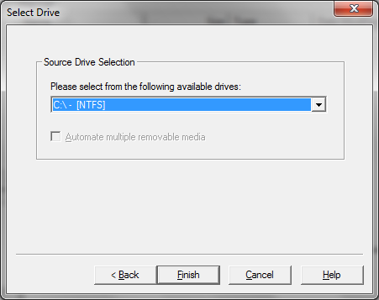

1. In the Create Image dialog, click Add.



* You can compare the stored hashes of your image content by checking the Verify images after they are created box. If a file doesn’t have a hash, this option will generate one.
* You can list the entire contents of your images with path, creation dates, whether files were deleted, and other metadata. The list is saved in a tab-separated value format

1. Select the type of image you want to create, and then click Next.

**Note:** If you are creating an image of a CD or DVD, this step is skipped because all CD/DVD images are created in the IsoBuster CUE format.



The raw image type is not compressed. If you select the Raw (dd) type, be sure to have adequate space for the resulting image.

If you select SMART or E01 as the image type, complete the fields in the Evidence Item Information dialog, and click **Next**.

**Raw (dd):** This is the image format most commonly used by modern analysis tools. These raw file formatted images do not contain headers, metadata, or magic values. The raw format typically includes padding for any memory ranges that were intentionally skipped (i.e., device memory) or that could not be read by the acquisition tool, which helps maintain spatial integrity (relative offsets among data).

**SMART:** This file format is designed for Linux file systems. This format keeps the disk images as pure bitstreams with optional compression. The file consists of a standard 13-byte header followed by a series of sections. Each section includes its type string, a 64-bit offset to the next section, its 64-bit size, padding, and a CRC, in addition to actual data or comments, if applicable.

**E01:** this format is a proprietary format developed by Guidance Software’s EnCase. This format compresses the image file. An image with this format starts with case information in the header and footer, which contains an MD5 hash of the entire bit stream. This case information contains the date and time of acquisition, examiner’s name, special notes and an optional password.

**AFF:** Advance Forensic Format (AFF) was developed by Simson Garfinkel and Basis Technology. Its latest implementation is AFF4. The goal is to create a disk image format that does not lock the user into a proprietary format that may prevent them from being able to properly analyze it.

1. In the Image Destination Folder field, type the location path where you want to save the image file, or click **Browse** to find to the desired location.

**Note:** If the destination folder you select is on a drive that does not have sufficient free space to store the entire image file, FTK Imager prompts for a new destination folder when all available space has been used in the first location.

1. In the Image Filename field, specify a name for the image file but do not specify a file extension.
2. In the Image Fragment Size field, specify the maximum size in MB for each fragment of the image file. The s01 format is limited by design to sizes between 1 MB and 2047 MB (2 GB). Compressed block pointers are 31- bit numbers (the high bit is a compressed flag), which limits the size of any one segment to two gigabytes.

**Tip:** If you want to transfer the image file to CD, accept the default fragment size of 650 MB.

1. Click **Finish**. You return to the Create Image dialog.
2. To add another image destination (i.e., a different saved location or image file type), click **Add**, and repeat steps 5– 10. To make changes to an image destination, select the destination you want to change and click **Edit.**

To delete an image destination, select the destination and click **Remove**.

1. Click **Start** to begin the imaging process. A progress dialog appears that shows the following:

􀂊 The source that is being imaged

􀂊 The location where the image is being saved

􀂊 The status of the imaging process

􀂊 A graphical progress bar

􀂊 The amount of data in MB that has been copied and the total amount to be copied

􀂊 Elapsed time after the imaging process began

􀂊 Estimated time left until the process is complete

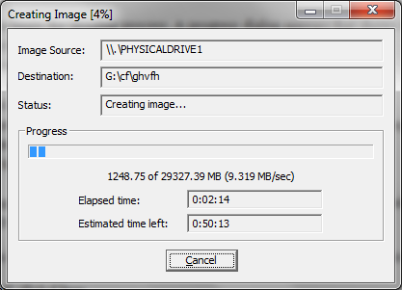

1. After the images are successfully created, click Image Summary to view detailed file information, including MD5 and SHA1 checksums.

**Note:** This option is available only if you created an image file of a physical or logical drive.

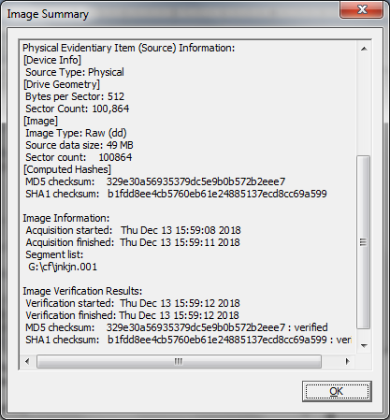

1. When finished, click **Close**

Note that the image file (*.001) as well as the image summary file from above (*.txt) have been saved onto the ‘Drive’. The .001 extension may be left as is, or can be changed to .dd. The .001 extension is used due to the fact that many times the file to be imaged is very large and must be split into multiple chunks. In that case, you would have *.001, *.002, etc.

**Practical No 2**

**Aim: Analyze Forensic Image:**

Click on Add Evidence Item to add evidence from disk, image file or folder.

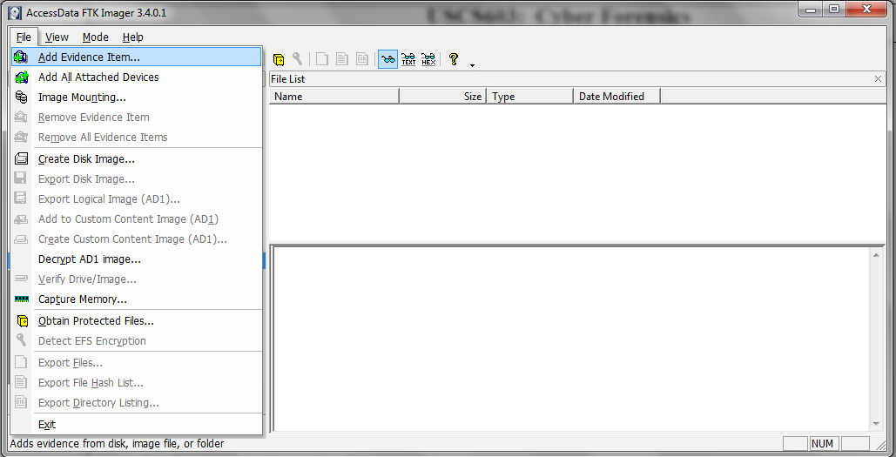

Now select the source evidence type as physical drive, logical drive or image file. We have selected image file and click on next.

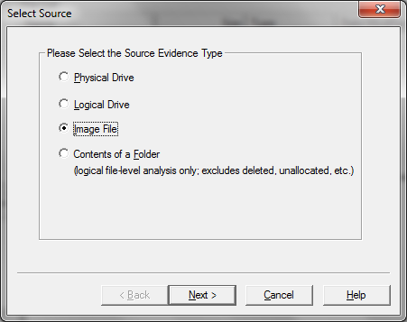

Select virtual drive image & click on open option. Select the source path and click on finish.

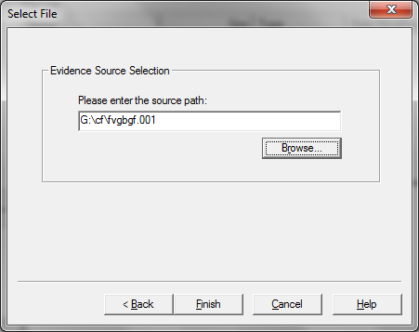

Now select Evidence Tree and analyze the virtual disk as physical disk.

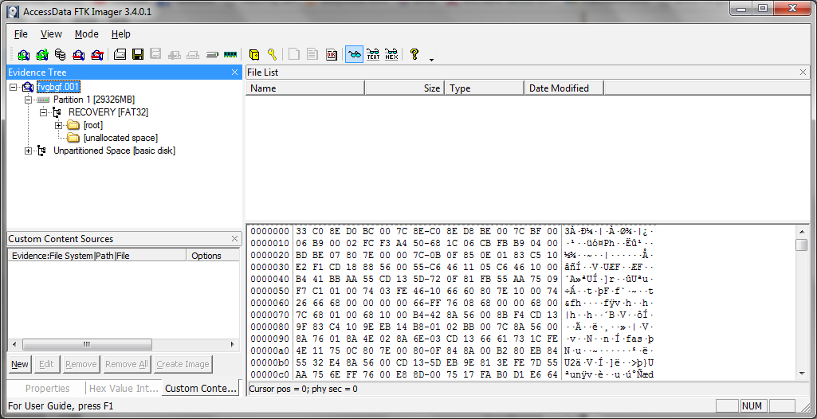

Similarly to add raw image select again add evidence item and click on image file and click on open option.

Click on finish.

Now raw image will be added as physical drive to analyze.

**Practical No 3**

**Case Study: Unraveling a Cybersecurity Intrusion at XYZ Corporation**

**Introduction:** This Case study aims that systematically investigating and understanding the details of the cybersecurity incident. In the dynamic landscape of cybersecurity, the ability to respond swiftly to potential security breaches is critical. XYZ Corporation, a multinational company, recently discovered irregularities within its internal network. Unusual data transfers, unauthorized access attempts, and anomalies in system logs prompted immediate concerns about a potential security breach. This case study details the steps taken by XYZ Corporation's cybersecurity team to conduct a comprehensive digital forensics investigation.

**Background:** XYZ Corporation operates in multiple countries, handling sensitive information and proprietary data. The company's cybersecurity infrastructure is designed to detect and respond to potential threats proactively. However, the recent anomalies in network activities raised alarms, triggering a rapid response from the cybersecurity team. The primary objectives include identifying the source of the compromise, assessing the extent of the breach, and gathering evidence to support potential legal actions.

**Initial Response:**

1. **Incident Identification:**
   * Unusual data transfers and unauthorized access attempts were initially detected through automated monitoring tools.
   * System logs indicated anomalies and patterns inconsistent with regular network activities.
2. **Isolation of Affected Systems:**
   * To prevent further potential damage, the affected systems were immediately isolated from the network.
   * The isolation process involved disconnecting the compromised systems to contain the possible spread of the intrusion.

**Digital Forensics Investigation:**

1. **Forensic Team Activation:**
   * Upon identifying the potential breach, XYZ Corporation activated its cybersecurity incident response team, including digital forensics experts.
2. **Evidence Preservation:**
   * To ensure the integrity of potential evidence, the digital forensics team employed write blockers on the compromised systems' storage devices.
   * This step aimed to prevent unintentional modifications to the data during the acquisition process.
3. **Forensic Imaging with EnCase:**
   * EnCase, a renowned digital forensic software, was employed for acquiring forensic images of the affected systems' storage.
   * Write-protected storage devices were connected to forensic workstations running EnCase to initiate the imaging process.
4. **Verification of Write Protection:**
   * The forensics team verified the functionality of write blockers by attempting to write to the storage devices.
   * Successful prevention of changes confirmed the write blockers were operating correctly.
5. **Acquisition Settings in EnCase:**
   * Forensic experts configured EnCase with specific acquisition settings, including the type of data to be collected and the destination for the forensic images.
6. **Initiation of Forensic Imaging:**
   * The forensic imaging process was initiated, copying the data from the compromised systems' storage to secure locations, creating forensically sound images.
7. **Analysis in EnCase:**
   * With the forensic images acquired, the cybersecurity team utilized EnCase for in-depth analysis.
   * File structures, metadata, and potential artifacts were examined to identify the nature and scope of the security breach.

**Conclusion:** This case study exemplifies the meticulous digital forensics process undertaken by XYZ Corporation's cybersecurity team in response to a potential security breach. By swiftly identifying and isolating affected systems and employing industry-standard tools like EnCase and write blockers, the team aimed to not only understand the source and extent of the compromise but also to gather irrefutable evidence for potential legal actions. The ability to conduct a thorough digital forensics investigation is paramount in the modern cybersecurity landscape, allowing organizations to respond effectively to cyber threats and safeguard their digital assets.

**Practical 4**

**Aim : Capturing and analyzing network packets using Wireshark (Fundamentals) :**

**Capturing Packets**

Capture traffic on your wireless network, click your wireless interface.

You can configure advanced features by clicking Capture > Options, but this isn’t necessary for now.

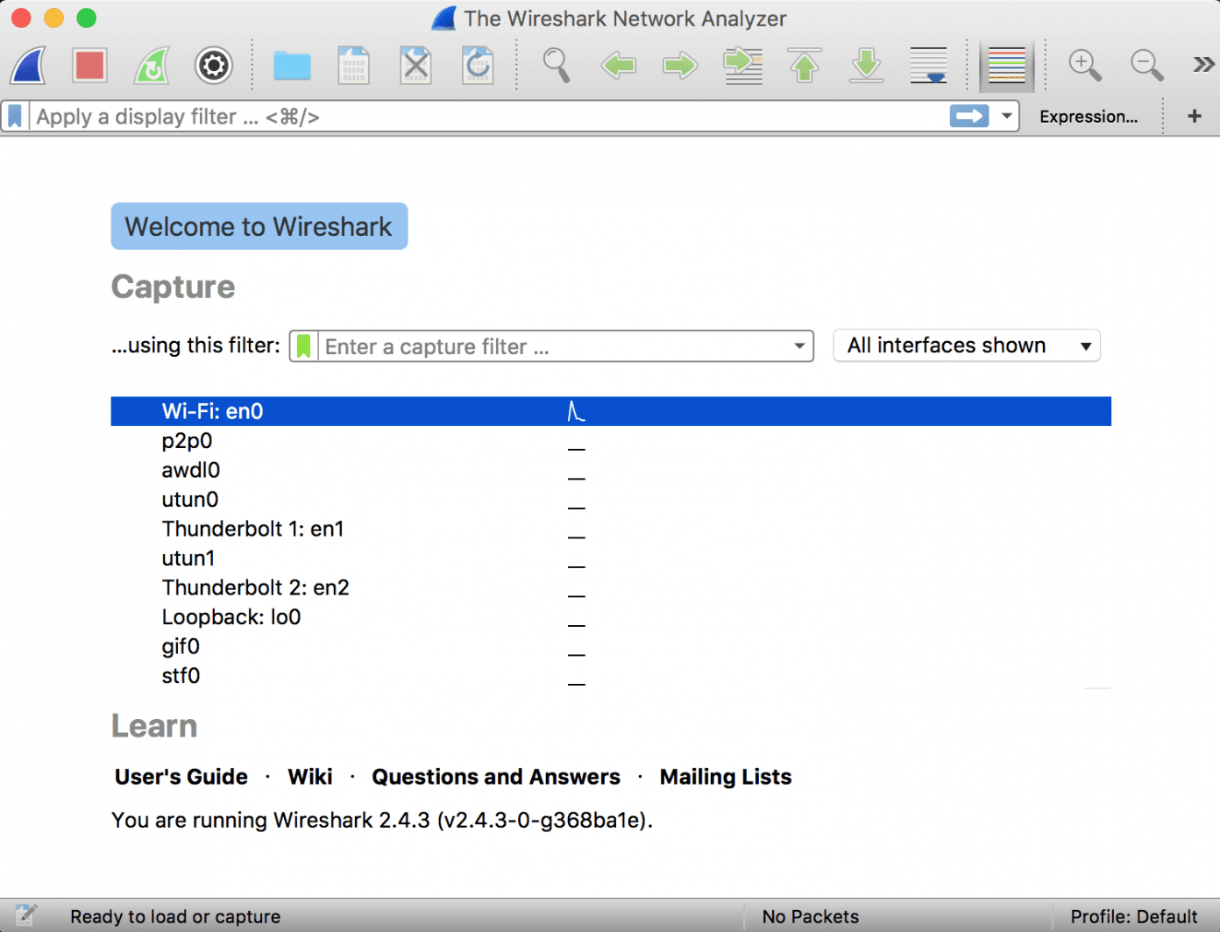

As soon as you single-click on your network interface’s name, you can see how the packets are working in real time. Wireshark will capture all the packets going in and out of our systems.

Promiscuous mode is the mode in which you can see all the packets from other systems on the network and not only the packets send or received from your network adapter. Promiscuous mode is enabled by default. To check if this mode is enabled, go to Capture and Select Options. Under this window check, if the checkbox is selected and activated at the bottom of the window. The checkbox says “Enable promiscuous mode on all interfaces”.

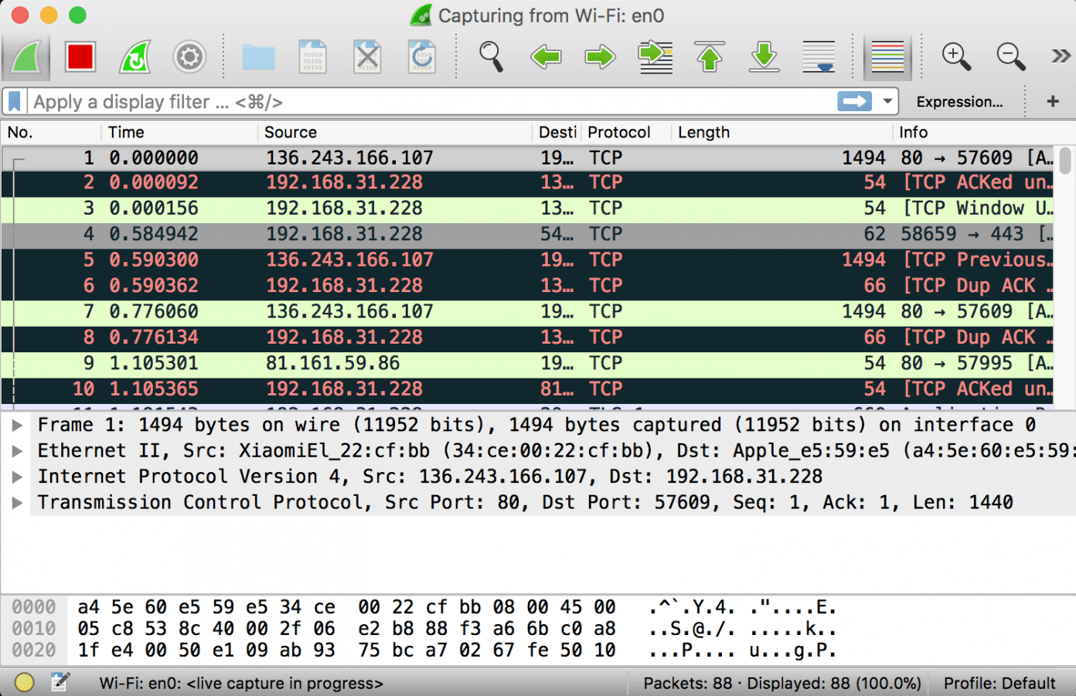

The red box button “STOP” on the top left side of the window can be clicked to stop the capturing of traffic on the network.

**Color Coding**

Different packets are seen highlighted in various different colors. This is Wireshark’s way of displaying traffic to help you easily identify the types of it. Default colors are:

* Light Purple color for TCP traffic
* Light Blue color for UDP traffic
* Black color identifies packets with errors – example these packets are delivered in an unordered manner.

To check the color coding rules click on View and select Coloring Rules. These color coding rules can be customized and modified to fit your needs.

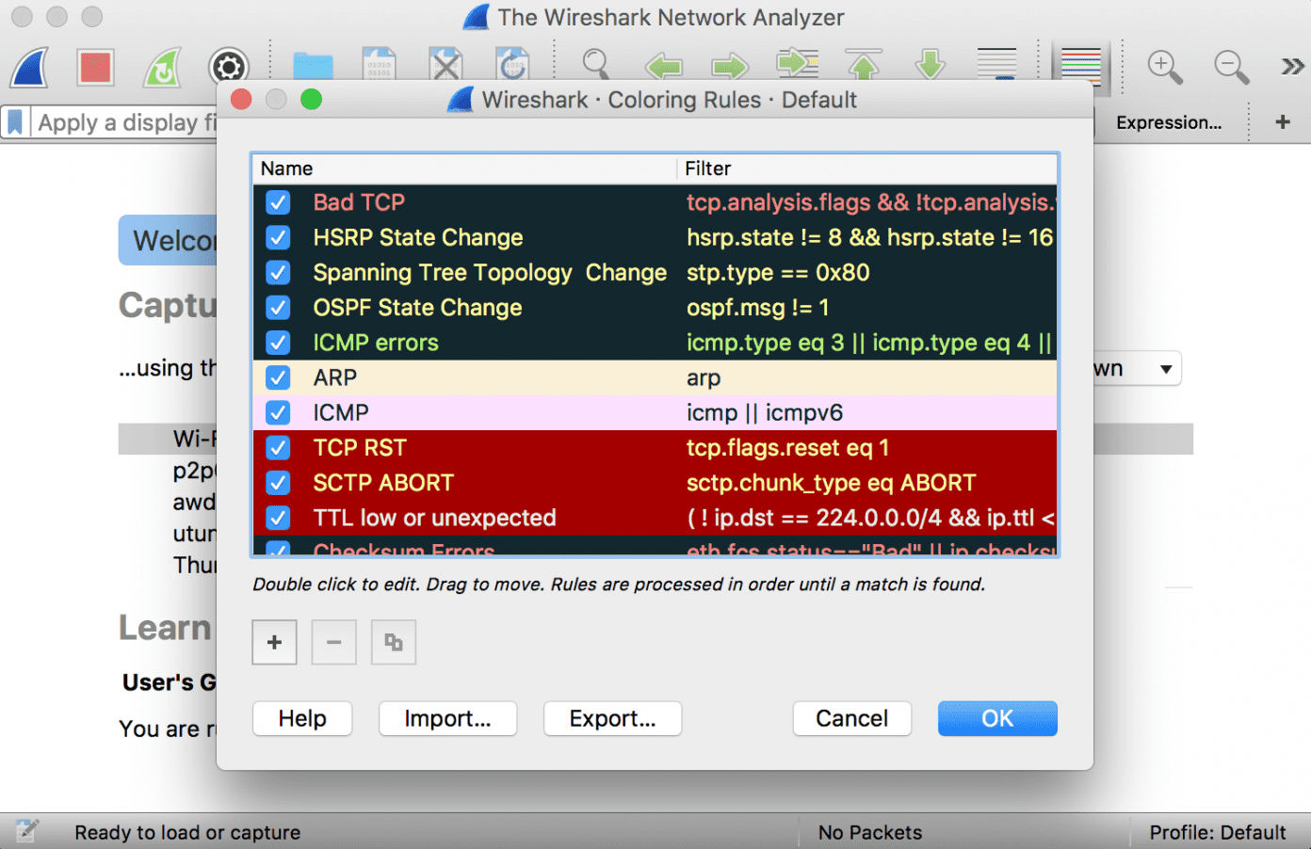

**Analyze the captured Packets:**

First of all, click on a packet and select it. Now, you can scroll down to view all its details.

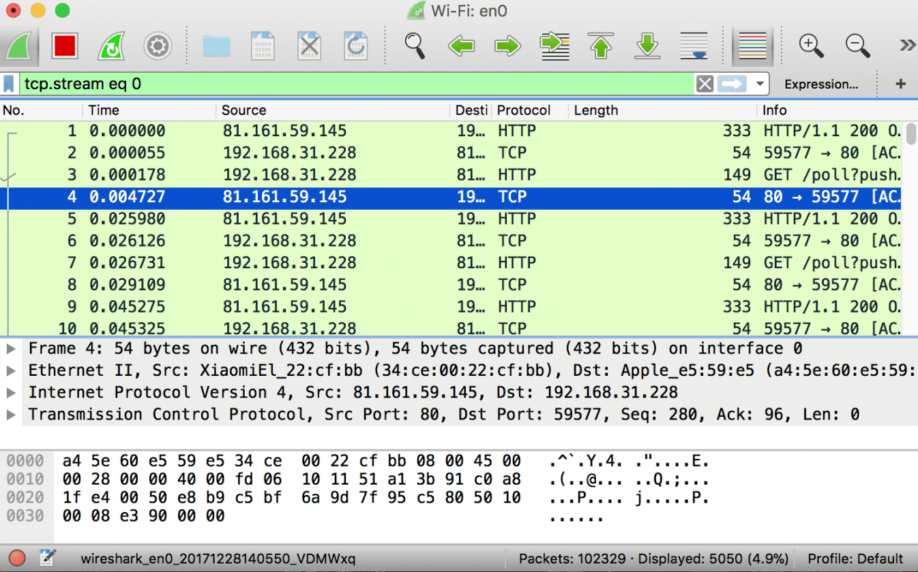

Filters can also be created from here. Right-click on one of any details. From the menu select Apply as Filter drop-down menu so filter based on it can be created.

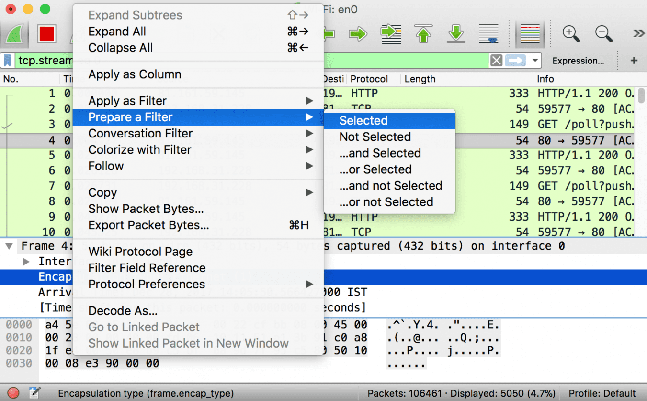

**Practical No :- 05**

**5. Analyze the packets provided in lab and solve the questions using Wireshark**

**What web server software is used by** [**www.snopes.com**](http://www.snopes.com)**?**

The domain name be found from host header so we will set host header column where we will see all domain name

Open Wireshark 🡪 file 🡪 open 🡪 Asksnopes.pcapng

Select any http 🡪 right click 🡪 Apply as Column

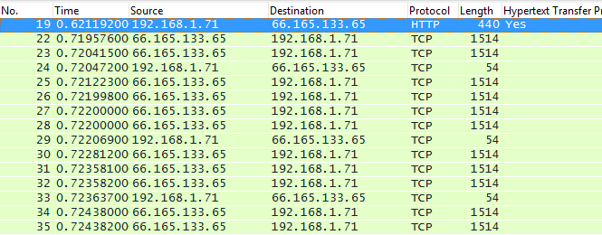

select http file 🡪 right click 🡪 follow TCP Stream

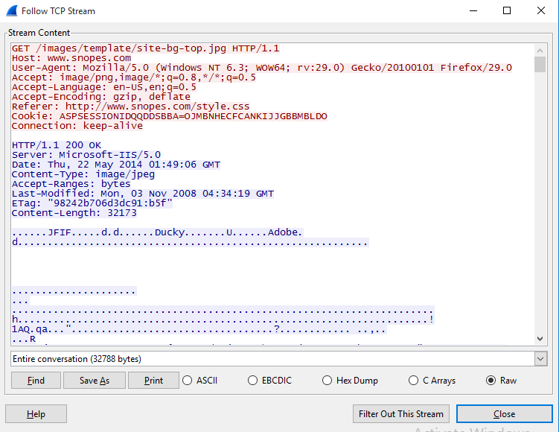

**About what cell phone problem is the client concerned?**

Client talking about cell so we search for cell keyword in whole packets.

frame.matches “(?i)cell

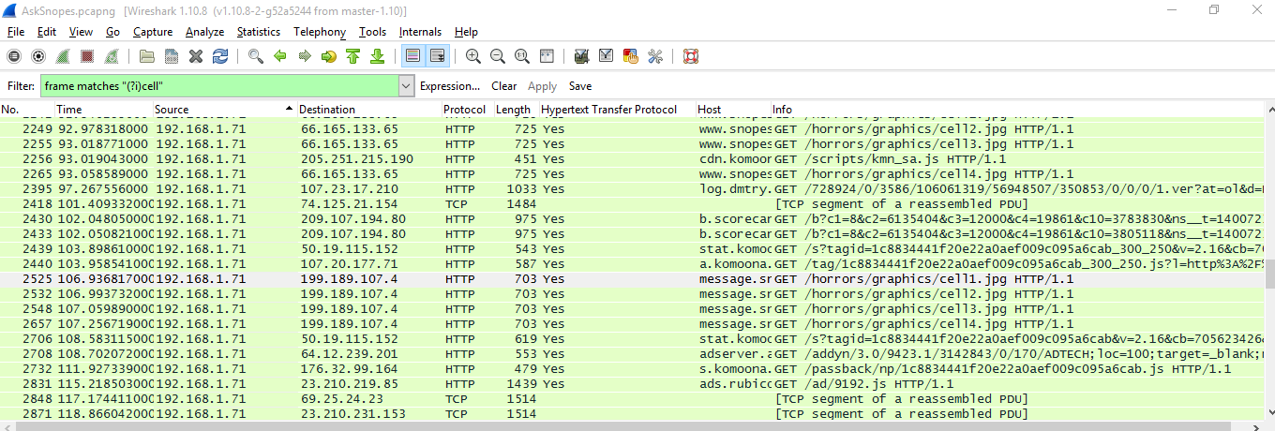

In the first HTTP request cell keyword is in URL and it was about cell phone charging issue.

**According to Zillow, what instrument will Ryan learn to play?**

frame.matches “(?i)zillow”

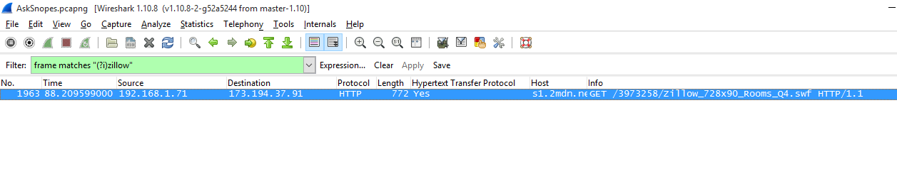

Open file 🡪 Export Object 🡪 HTTP 🡪 save All 🡪 select the folder to save

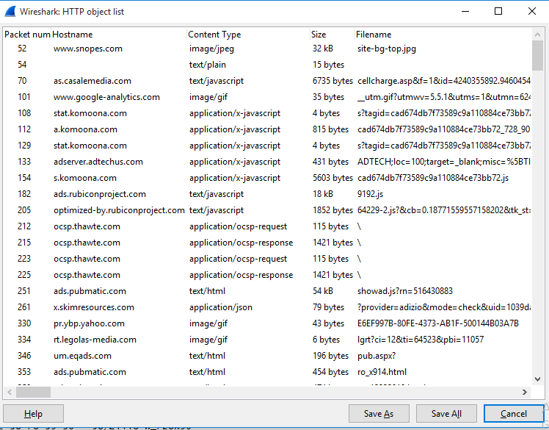

Open the folder 🡪 search for the file name zillow 🡪 open with browser



**How many web servers are running Apache?**

http.response

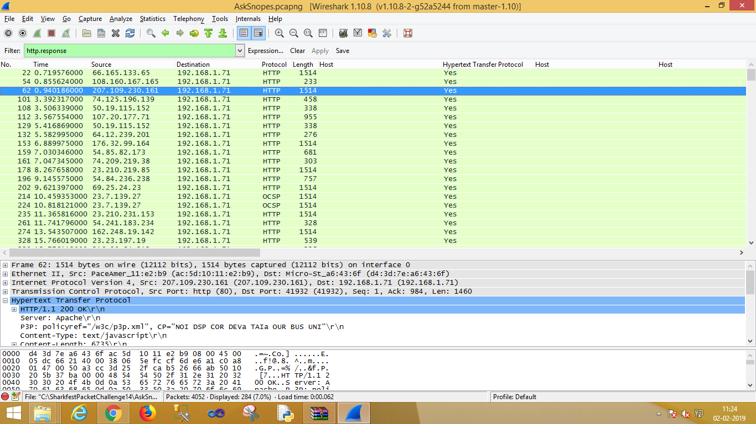

Select http 🡪 apply as column

http.server contains “Apache”

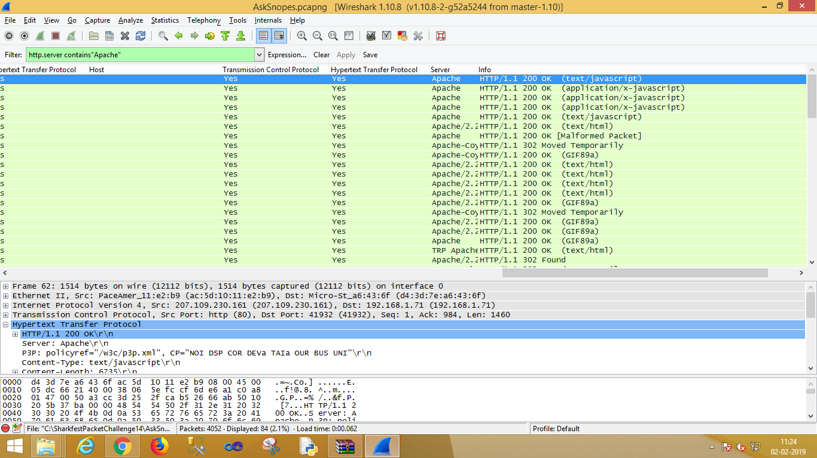

**PRACTICAL 6**

AIM :- Solve the Case study (image file) provide in lab using Encase Investigator or Autopsy Recovering and Inspecting deleted files

- Check for Deleted Files

- Recover the Deleted Files

- Analyzing and Inspecting the recovered files Perform this using recovery

Step 1 : Open Autopsy



Step 2 : Click on new case

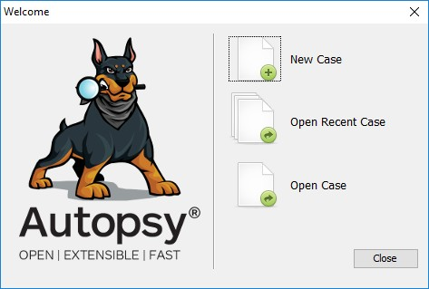

Step 3 : Enter details regarding the case and click on next button.

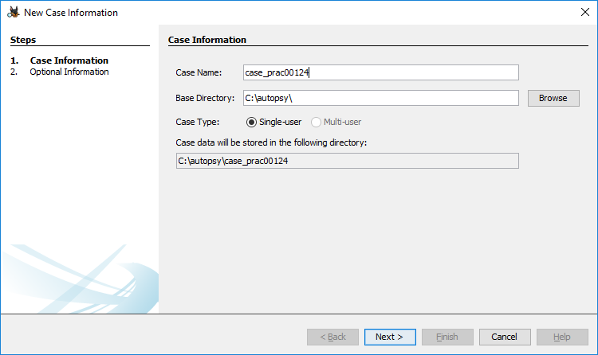

Step 4 : Enter further details and click on next button

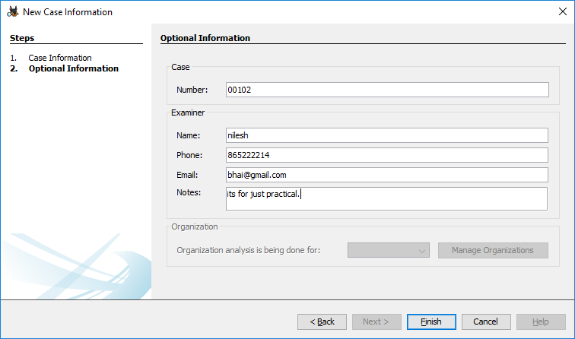

Step 5 : Now here we have to select Type of data source to add , in our case disk image or VM file and click on next

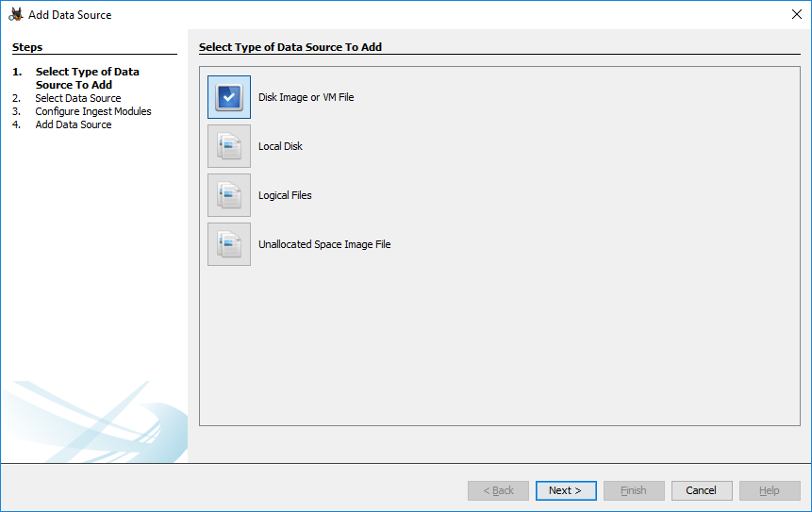

Step 6 : Now we have to select image file and click on next button

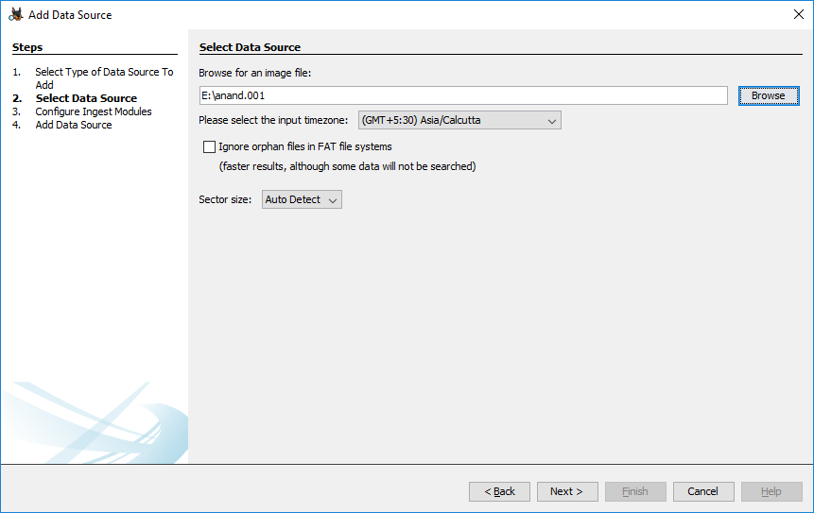

Step 7 : Now click on select all in order to Run ingest modules on: and click on next.

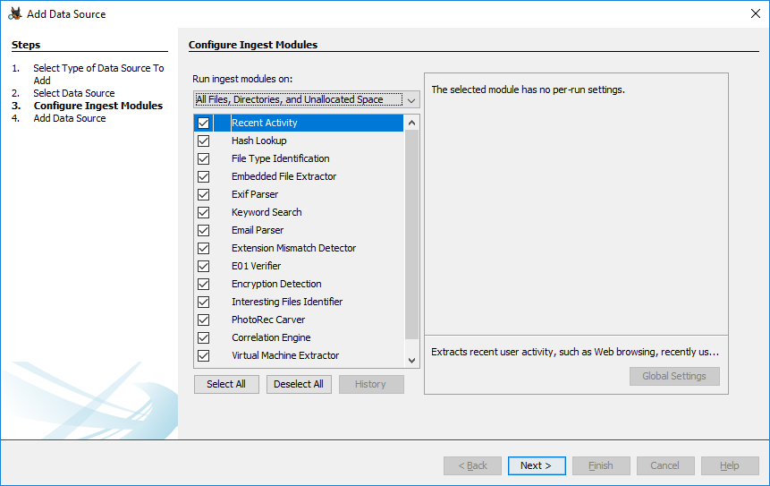

Step 8 : Now click on finish

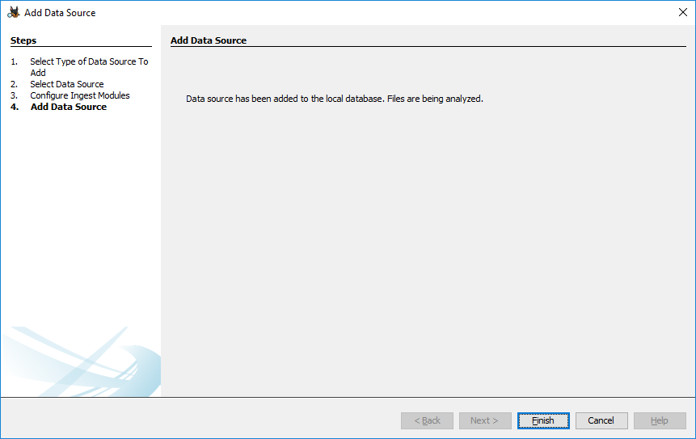

Step 9 : Now Autopsy window will appear and it will analyse the disk that we have selected .

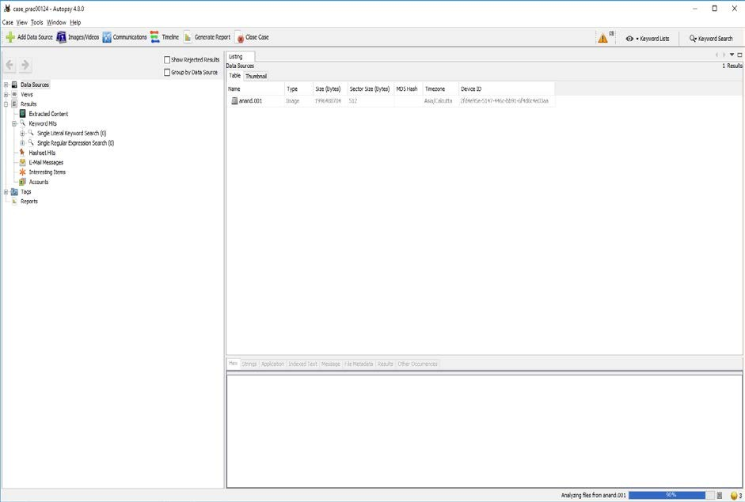

Step 10 : All image files appears in the Table tab. Select any file to see the data

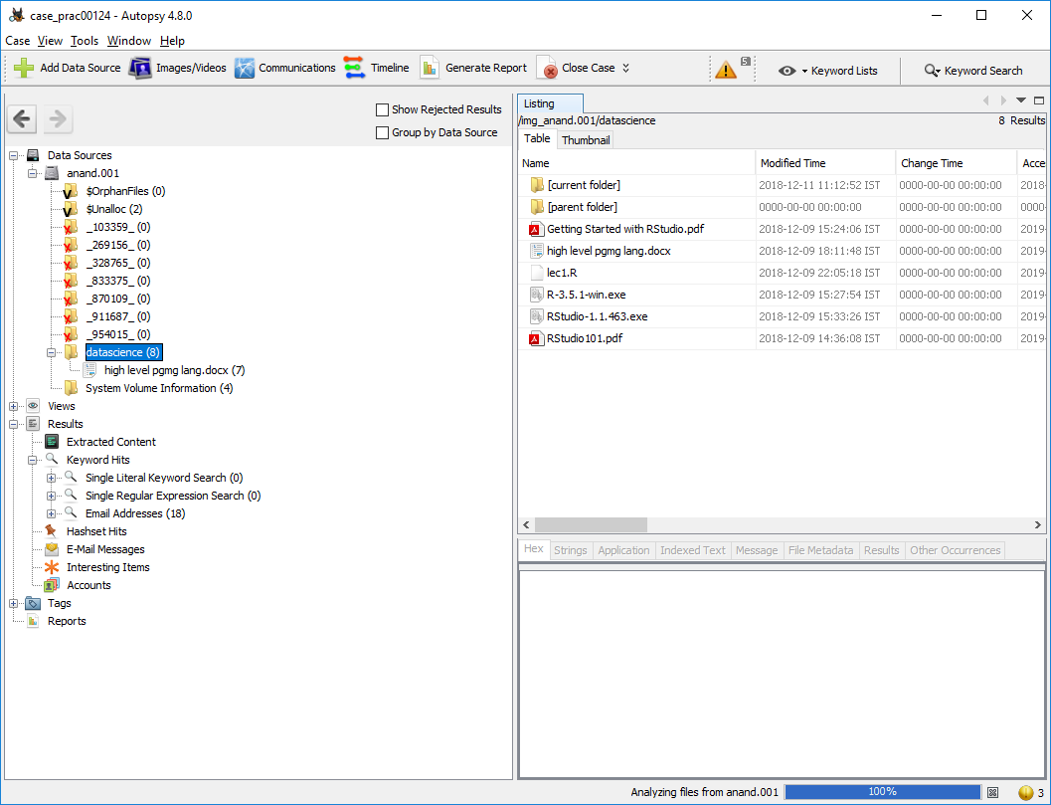

Step 11 : Expand the tree from left side panel to view the document files.

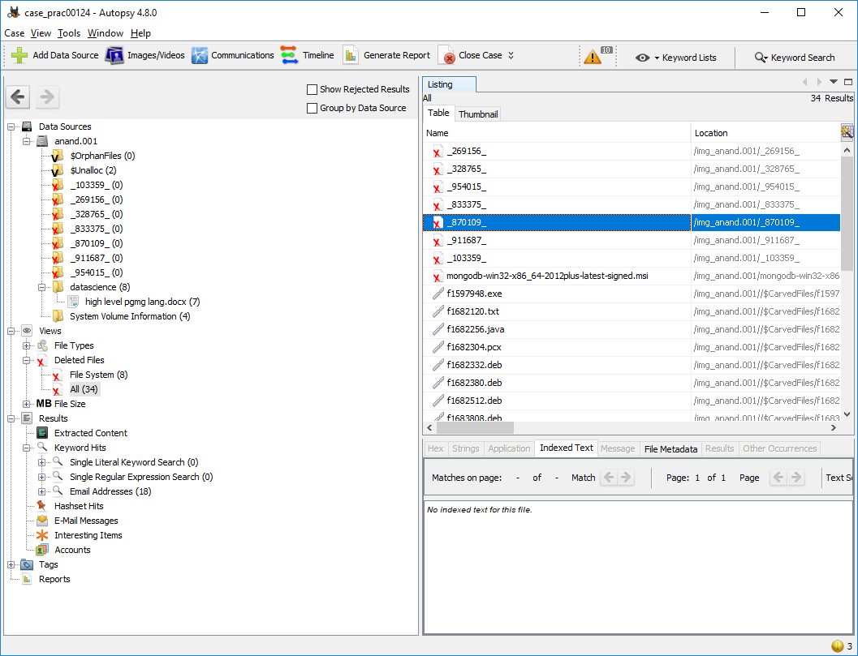

Step 12 : To recover the files , go to view code à Deleted files node , here select any file and right click on it then select Extract files option

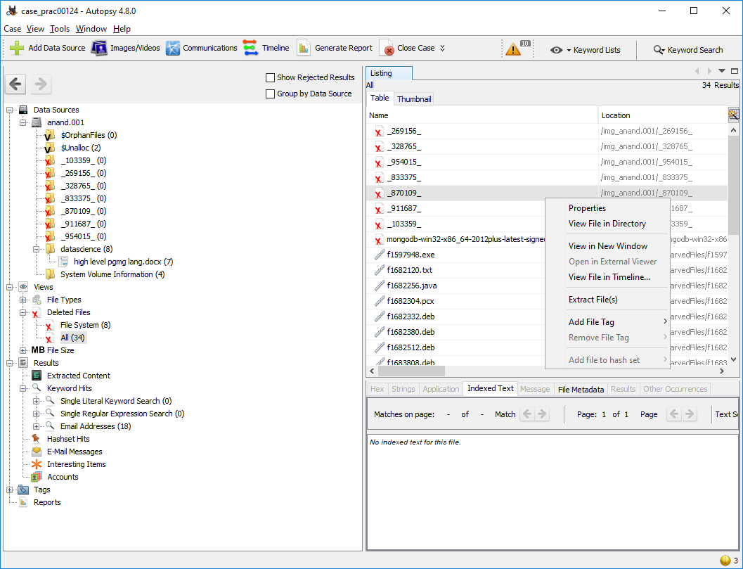

Step 13: Select Path where you want to save extracted file and click on save .

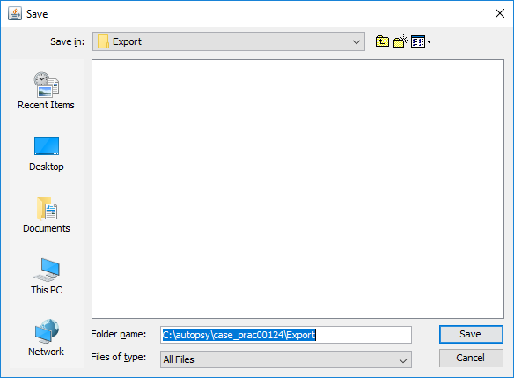

Step 14 : Now click on OK

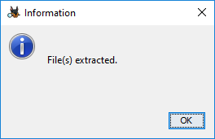

Step 15 : Now go to C:\autopsy\case_prac00124\Export folder to see recover file

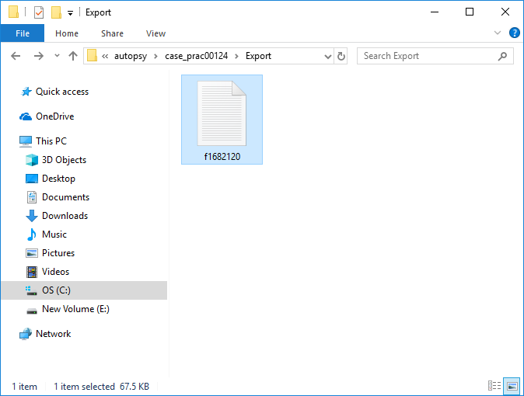

Step 16 : Click on generate report from Autopsy window and select the Excel format and click on next

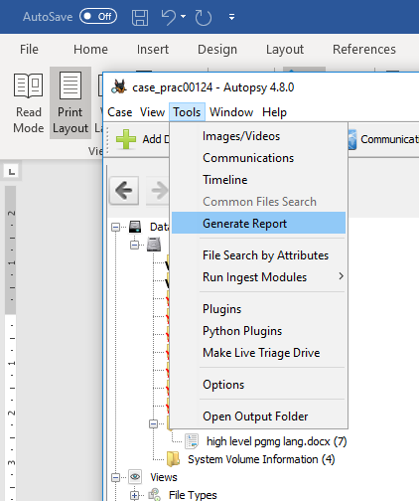

Step 17 : This window will appear

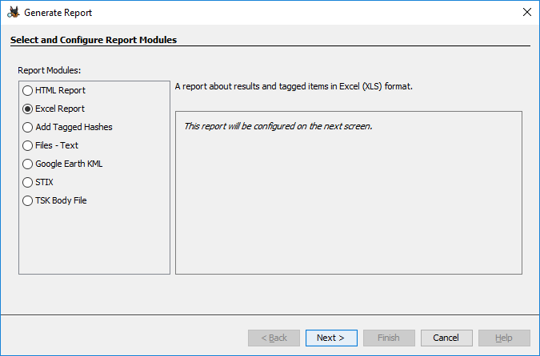

Step 18 : Now report is generated so click on close button. We can see the Report on Report Node

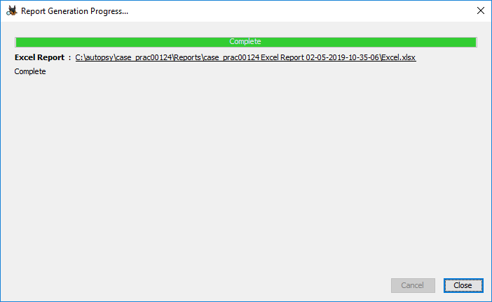

Step 19 : Click on report

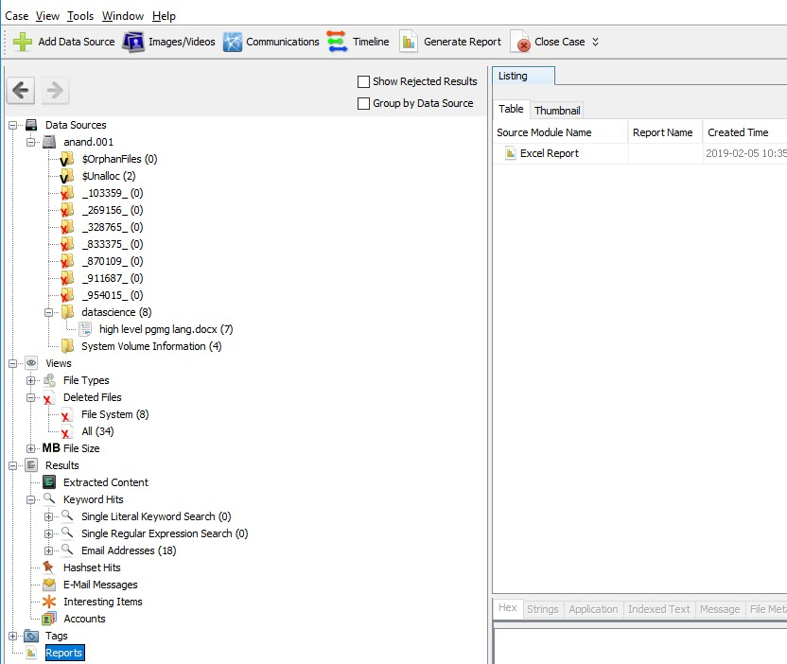

**Practical No. 7**

**Perform Data Acquisition using SATA Write Blocker**

**Introduction:**

Write Blocker is a tool designed to prevent any write access to the hard disk, thus permitting read-only access to the data storage devices without compromising the integrity of the data. A write blocking if used correctly can guarantee the protection of the chain of custody. NIST has issued a set of general guidelines for write blocking requirements:

1. The write-blocker tool shall not allow a protected drive to be changed.
2. The write-blocker tool shall not prevent any operations to a drive that is not protected.
3. The write-blocker tool shall not prevent obtaining any information from or about any drive.

**Types of Write Blocker:**

**Hardware Write Blocker and Software Write Blocker.** Both types of write blockers are meant for the same purpose that is to prevent any writes to the storage devices. Let’s discuss each type of write blocker in detail.

**Hardware write blockers** are used to intercept and block any modifying command from ever reaching the storage device. Some of its features include:

* They offer monitoring and filtering any activity that is transmitted or received between its interface connections to the computer and the storage device.
* They provide built-in interfaces to a number of storage devices.
* Hardware write blockers can connect to other types of storage with adapters.
* Hardware devices that write block also provide a visual indication of function through LEDs and switches. This makes them easy to use and makes functionality clear to users.

**The software blocker** is an application that is run on the operating system that implements a software control to turn off the write capability of the operating system. If you are using a software, write blocker, ensure to attach the external evidence collection drive prior to activating the software blocker as this will allow the external drive to be written to.

* If you are collecting data from a USB device such as a thumb drive, you need to activate the software or hardware blocker prior to connecting the device to the collection system. Importantly, make sure that you have already connected the external evidence collection drive and prepared it.

**SATA Write Blocker**

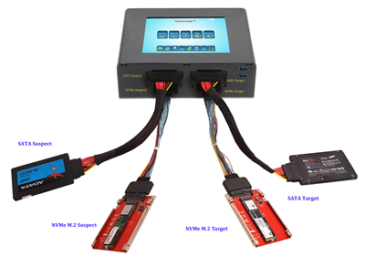

A **forensic disk controller** or hardware write-block device is a specialized type of computer hard disk controller made for the purpose of gaining read-only access to computer hard drives without the risk of damaging the drive's contents.

Go for a write blocker that allows the switching for the sake of convenience in the cases where you need to connect to a SATA or IDE Drives.

Practical No 8

Aim:- Using Sysinternals tools for Process Monitoring

Windows Sysinternals tools are utilities to manage, diagnose, troubleshoot, and monitor a Microsoft Windows environment.

The following are the categories of Sysinternals Tools:

* 1. File and Disk Utilities
  2. Process Utilities
  + **Monitor Live Processes : (Tool: ProcMon) To Do:**

1. Filter (Process Name or PID or Architecture, etc)
2. Process Tree
3. Process Activity Summary Count Occurrences

Output 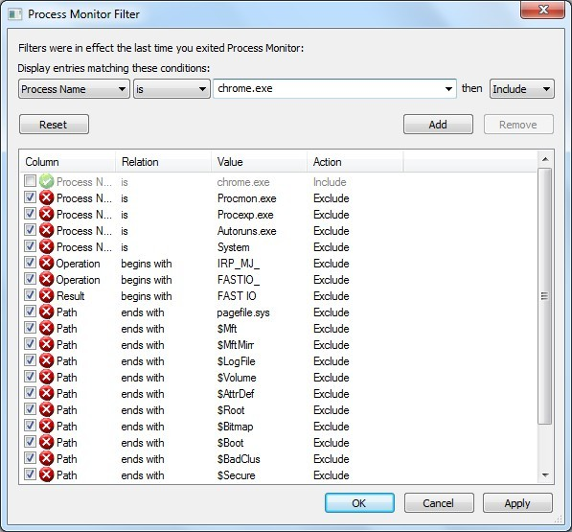

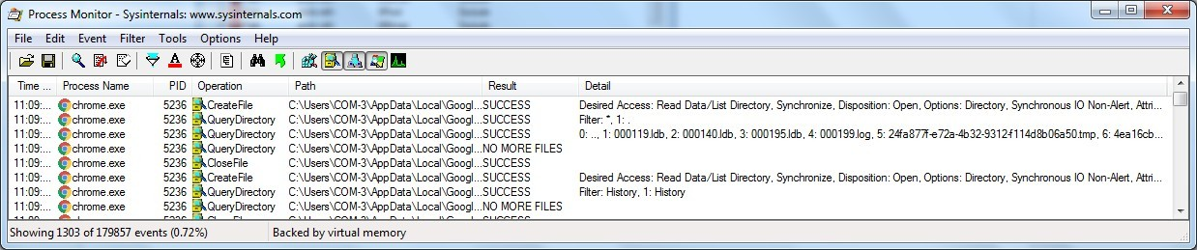

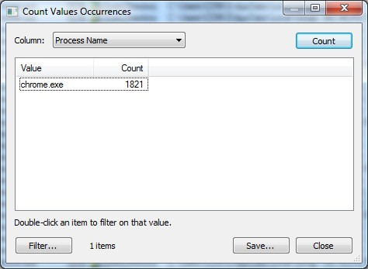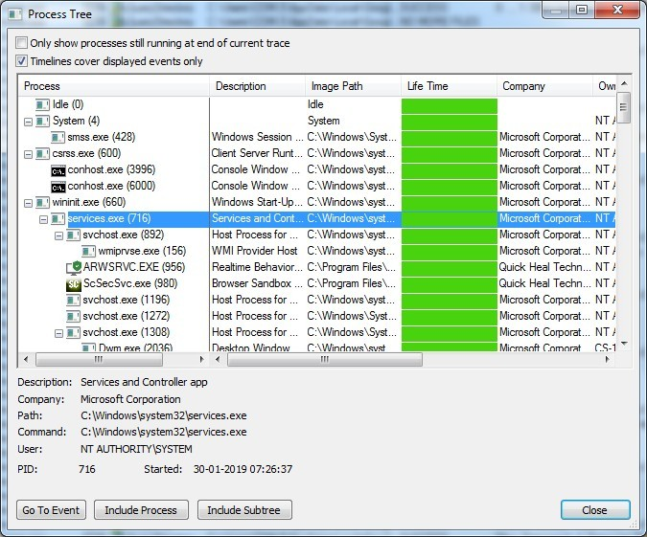

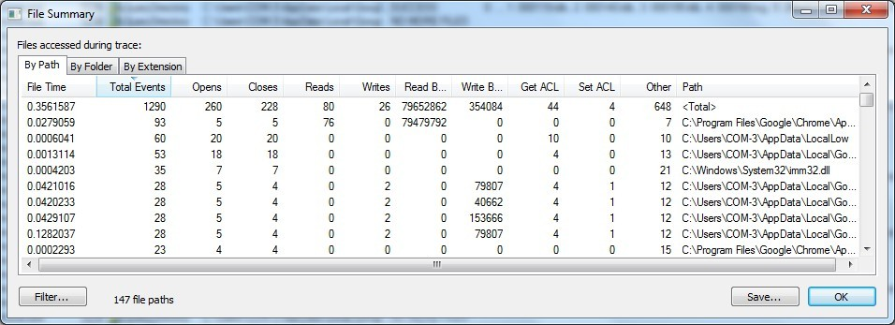

1. **Capture RAM (Tool: RAMCapture)**
   1. Click Capture
   2. Creates a .mem file of the system memory (RAM) utilized.

Output

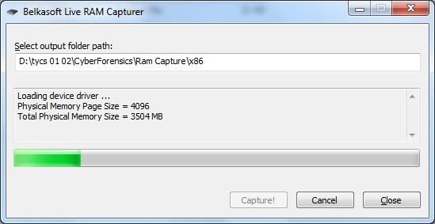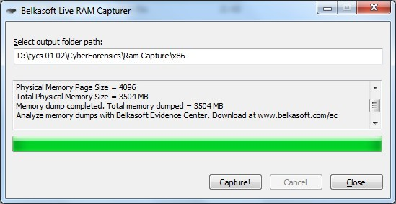

**Practical No 9**

**Aim: Network Tracking using Sysinternals tools**

1. **Capture TCP/UDP packets (Tool: TcpView) :**

**To Do:** 1. Save to .txt file.

2. Whois

**Output:**

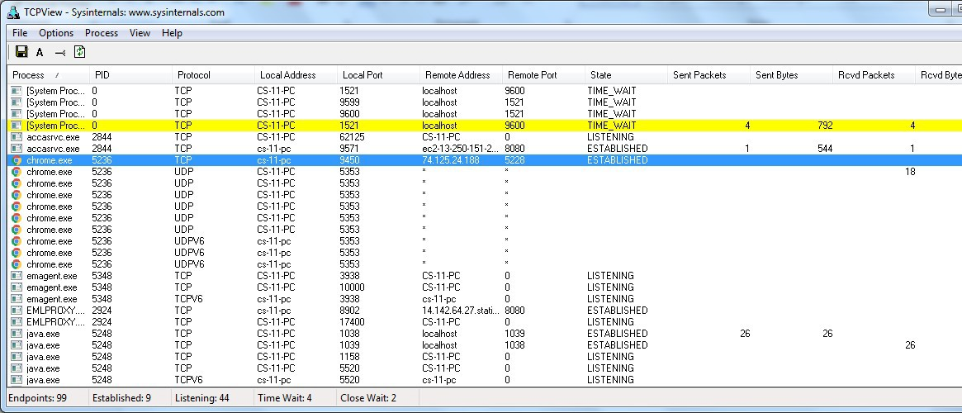

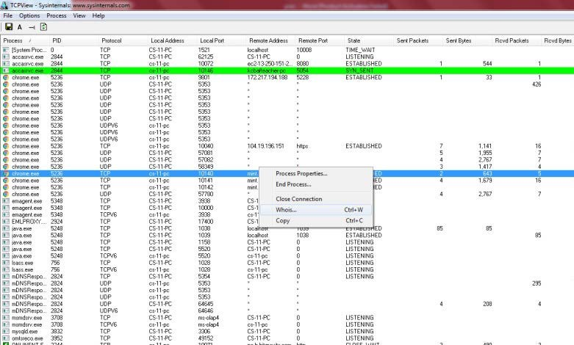

**Practical No 11**

**Aim :- Email Forensics**

* Mail Service Providers
* Email protocols
* Recovering emails

FTK can filter or find files specific to e-mail clients and servers. You can configure these filters when you enter search parameters.

Because of Jim’s responses to a poor performance review, the CEO of Superior Bicycles,Martha Dax, suspects he might have obtained sensitive information about the company’s business model that he’s leaking to a competitor.

Martha asked her CIO, to have an IT employee copy the Outlook .pst file from Jim Shu’s old computer to a USB drive.

To process this investigation, we need to examine the Jim_shu’s.pst file, locate the message, and export it for further analysis of its header to see how Jim might have received it.

## Recovering Email

Start AccessData FTK and click **Start a new case**, then click **OK**. Click **Next** until you reach the **Refine Case - Default** dialog box Click the **Email Emphasis** button , and then 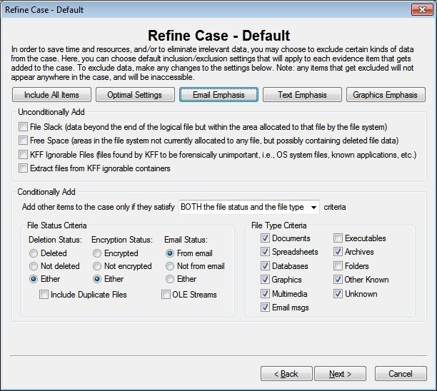click **Next .**

Click **Next** until you reach the **Add Evidence to Case** dialog box, and then click the **Add Evidence** button.

In the Add Evidence to Case dialog box, click the **Individual File**

option button, and then click **Continue**.

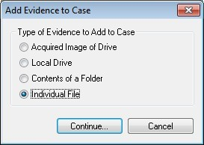

In the **Select File** dialog box, navigate to your work folder, click the

**Jim_shu’s.pst file**, and then click **Open**.

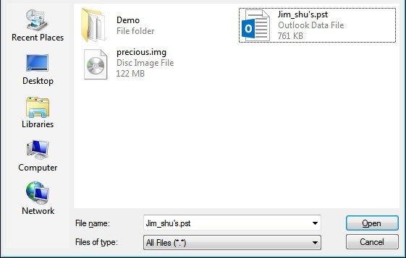

When the **Add Evidence to Case** dialog box opens, click **Next**. In the

**Case summary** dialog box, click **Finish**.

When FTK finishes processing the file, in the main FTK window, click the **E- mail Messages** button, and then click the **Full Path** column header to sort the records.

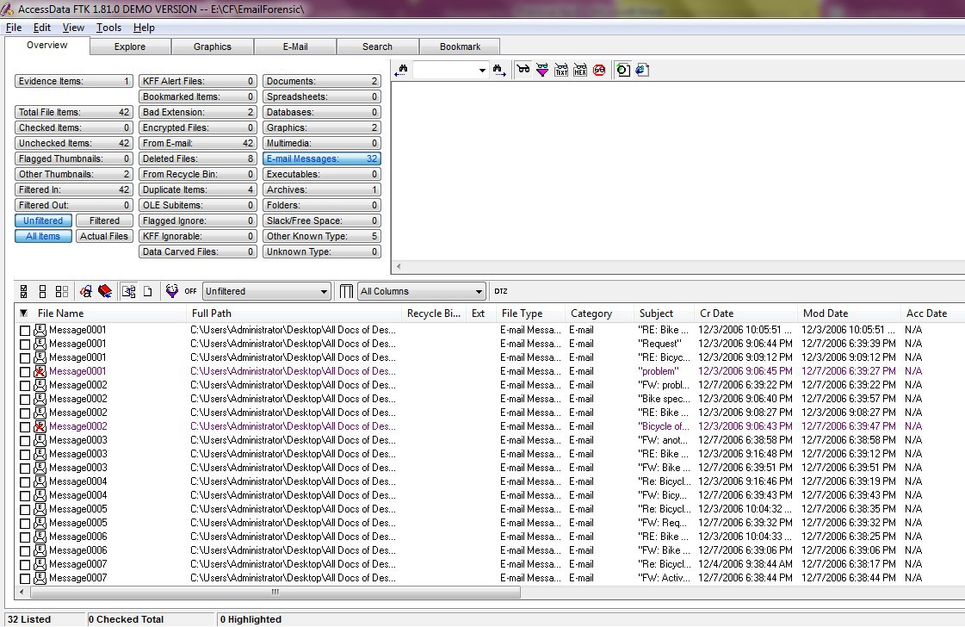

## For email recovery follow following steps:

Click the **E-Mail** tab. In the tree view, click to expand all folders, 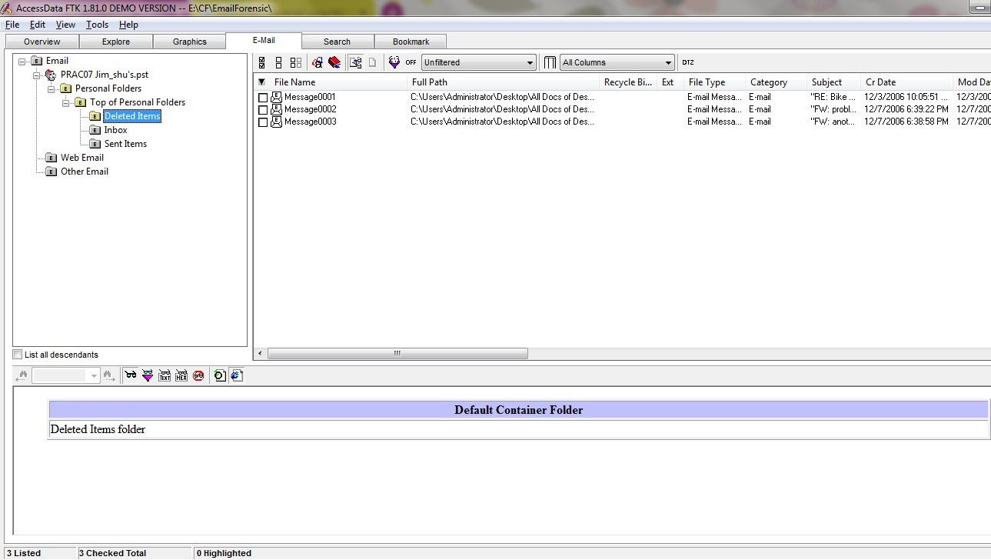and then click the **Deleted Items** folder.

Select any message say Message0001 right click and select option Launch. Detached Viewer and you can see detail of deleted message.

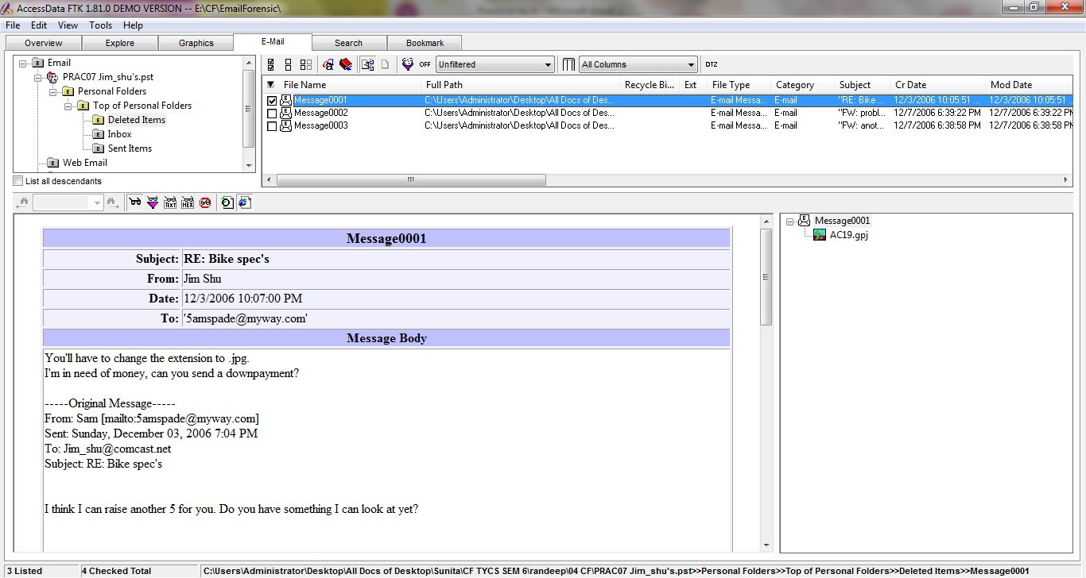

## Practical No 12

* **Aim: Analyzing email header**

## For analyzing header follow following: steps:

Click the **E-Mail** tab. In the tree view, click to expand all folders, and then click the **Inbox** folder.

In the File List pane at the upper right, click Message0003; as shown in the pane at the bottom, it’s from **Sam** and is addressed to [**Jim_shu@comcast.net.**](mailto:martha.dax@superiorbicycles.biz)

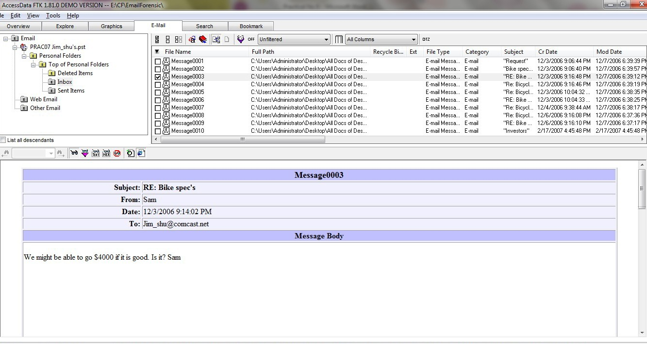

Right-click on any message say Message0003 in the File List pane and click Export File. In the Export Files dialog box, click OK.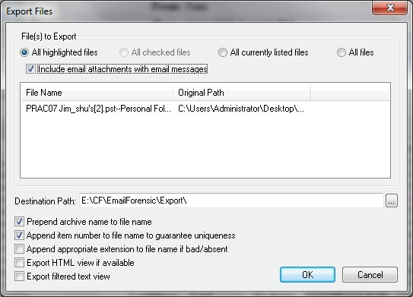

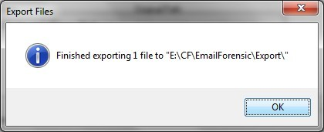

FTK saves exported files in the HTML format with no extension.

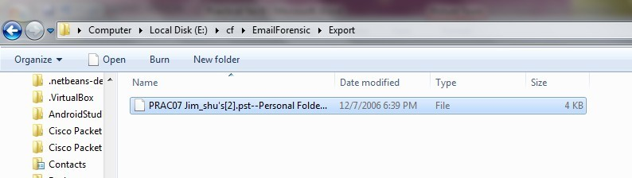

Right-click the Message0003 file and click Rename. Type Message0003.html and press Enter.

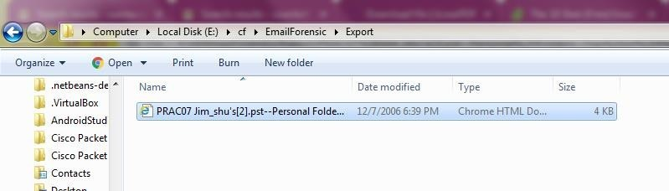

Double-click Message0003.html to view it in a Web browser.

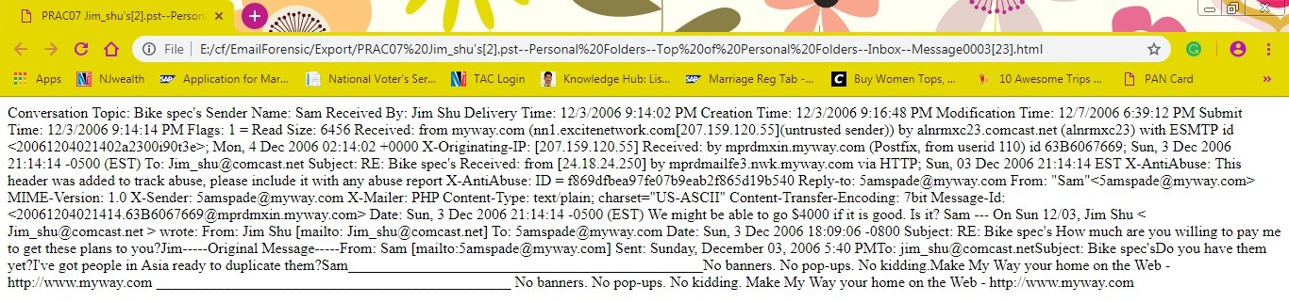

# PRACTICAL 13

Aim: Web Browser Forensics .

-Web Browser working

-Forensics activities on browser

-Cache / Cookies analysis

-Last Internet activity

## Steps:

1. Open BrowserHistoryExaminer.

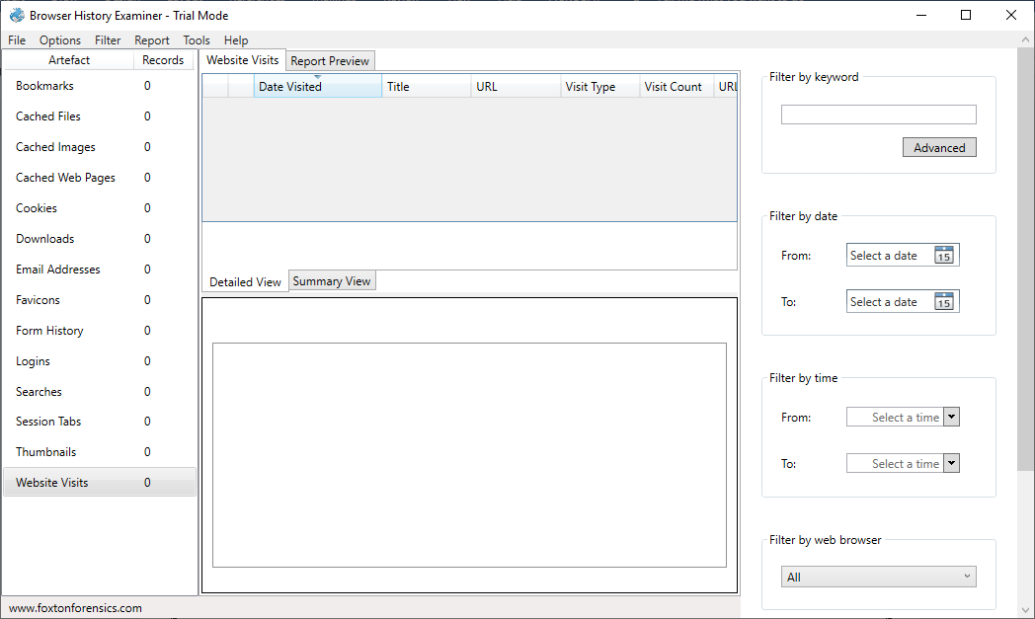

1. Click on file > Capture History

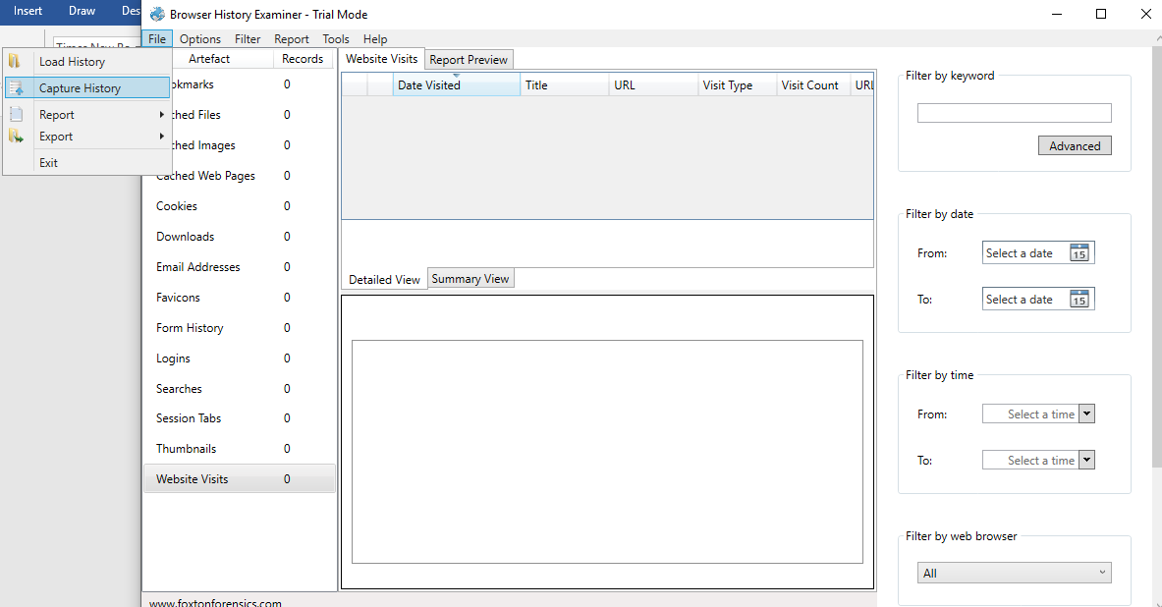

1. Select the capture folder and click on next.

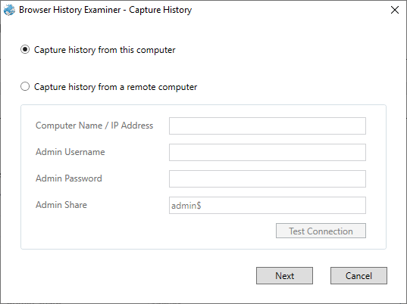

1. Enter the destination to capture the data.

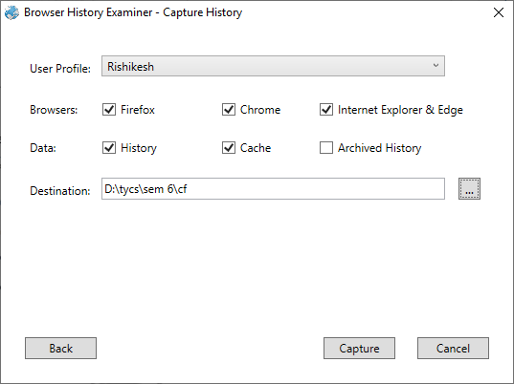

1. The History is been extracting.

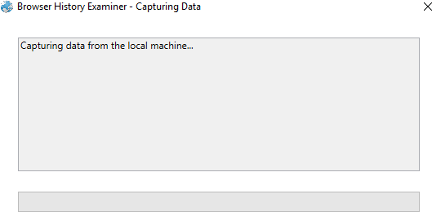

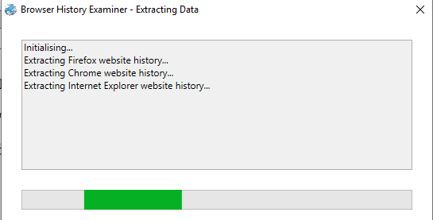

1. 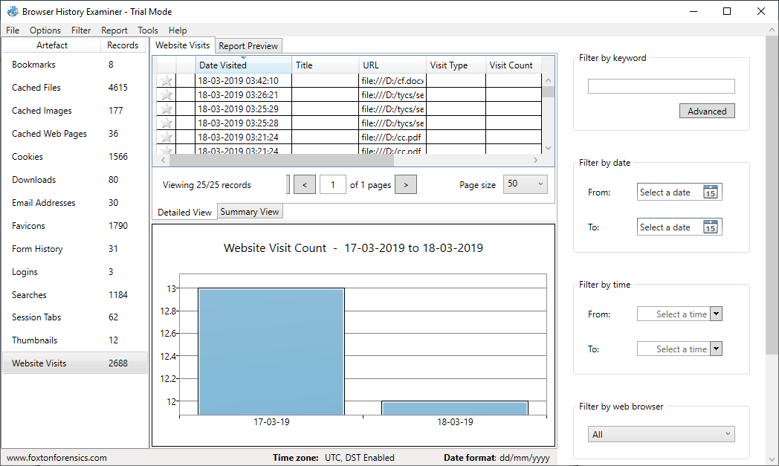The data has been retrieved.
2. On the left panel click on bookmarks.

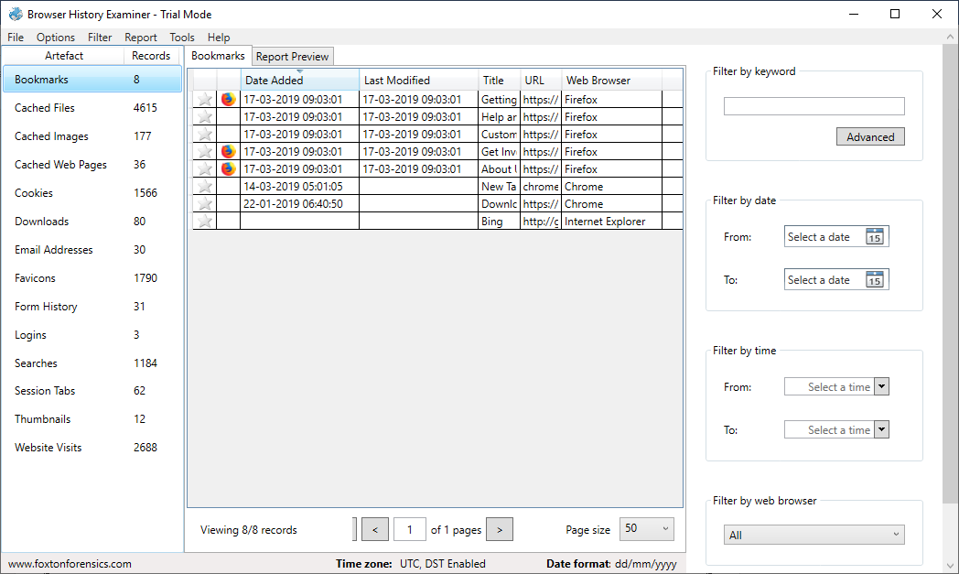

1. On the left panel click on cached files.

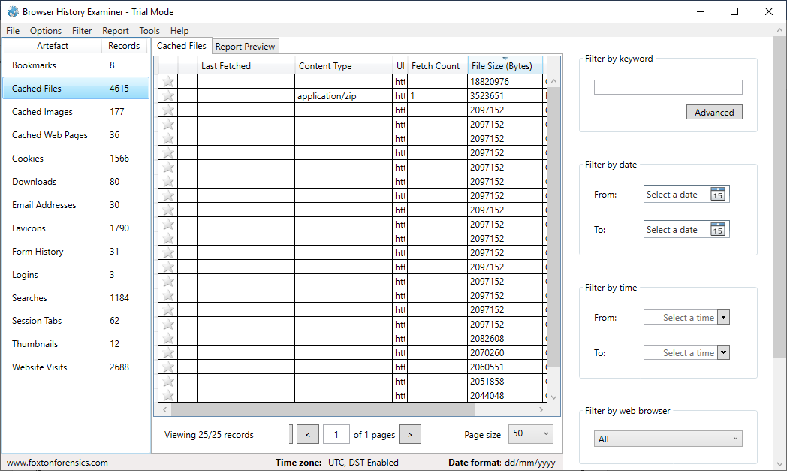

1. On the left panel click on cached images.

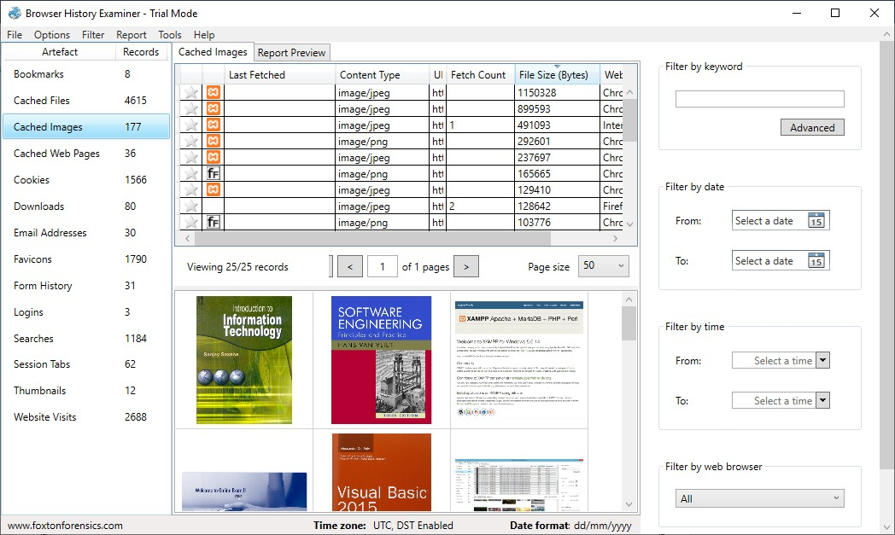

1. On the left panel click on cookies.

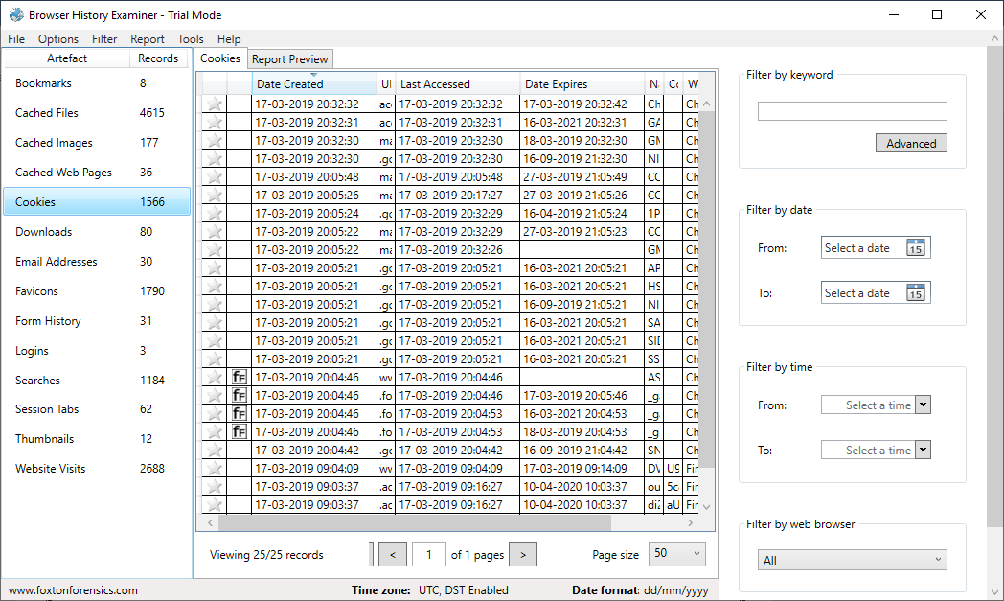

1. To Create Reports. Click on file > Report and save the report as pdf or html page.

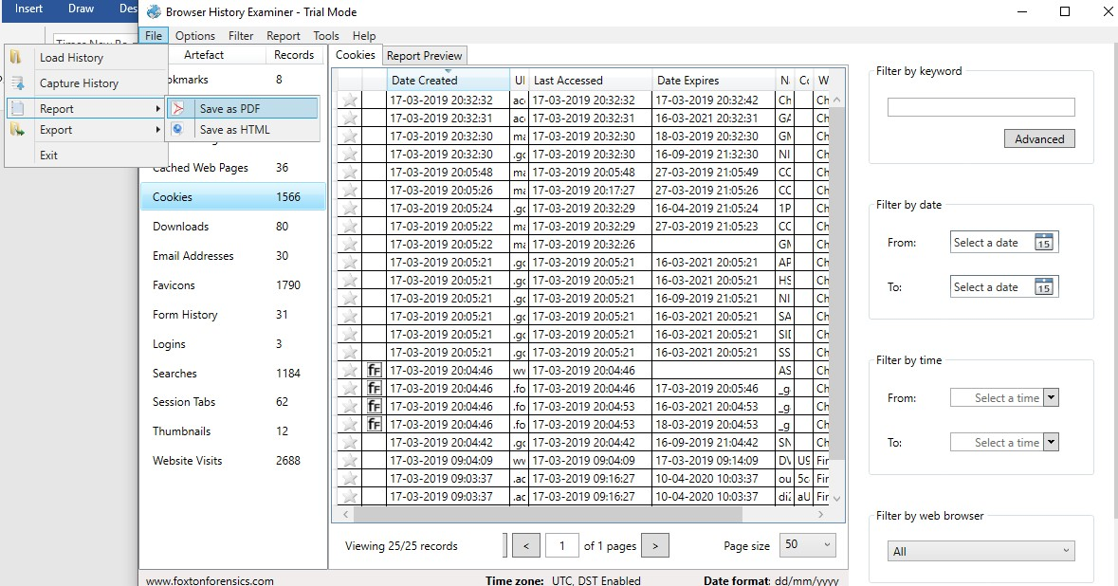

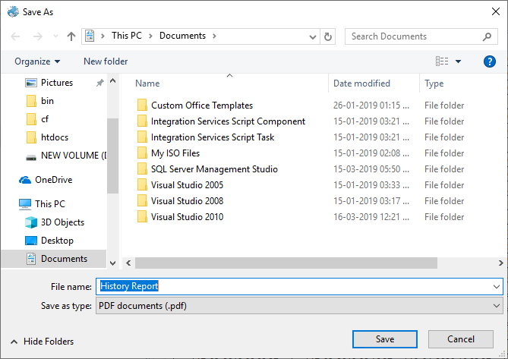

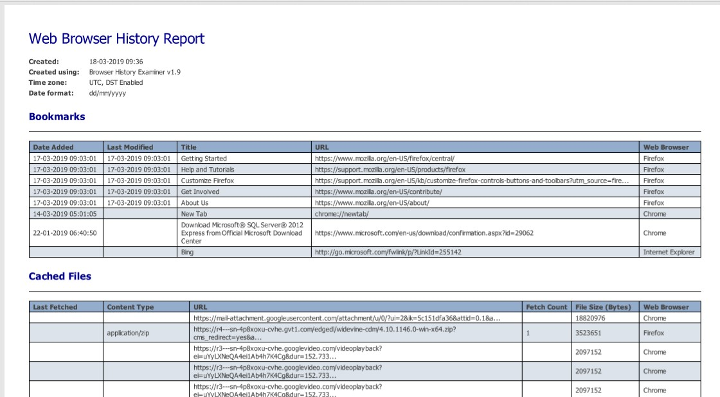

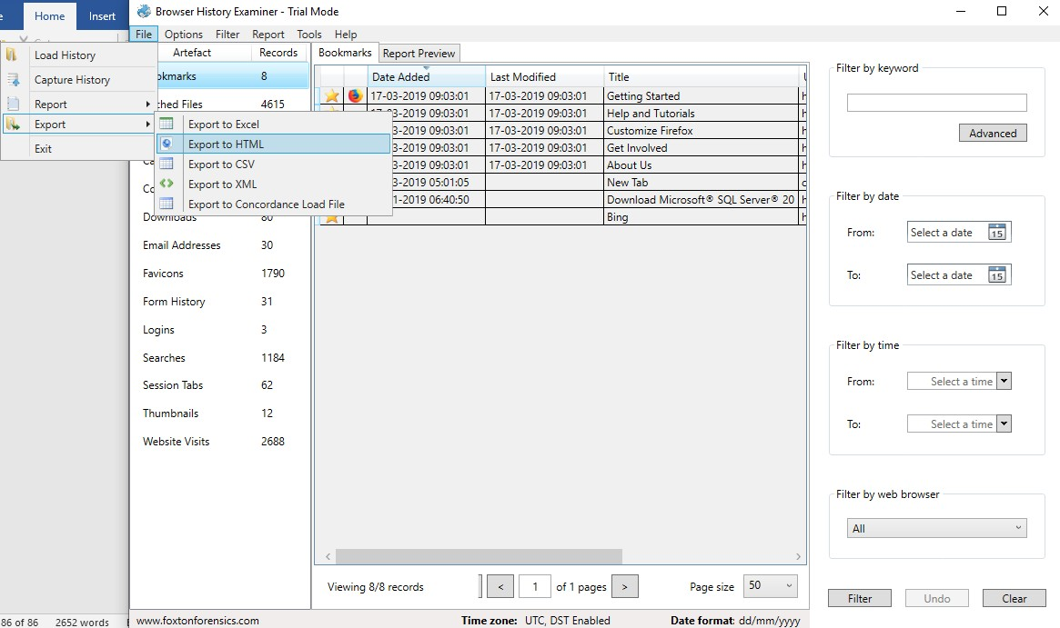

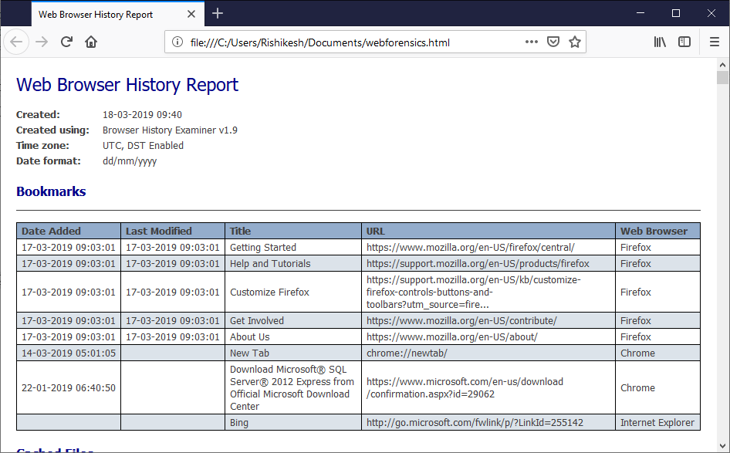

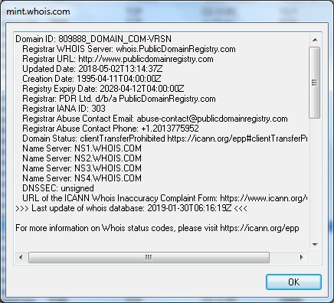

1. **Monitor Hard Disk (Tool: DiskMon) :**

**To Do:**

1. Save to .log file.
2. 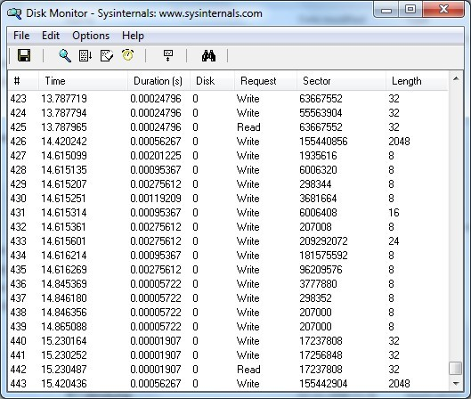Check operations performed in the disk as per time and sectors affected.

**Output :**

1. **Monitor Virtual Memory ( Tool : VMMAP) :**

**To Do:**

1. Options – Show Free & Unusable Regions
2. File-> Select Process e.g. chrome.exe
3. Save to .mmp file.

**Output :**

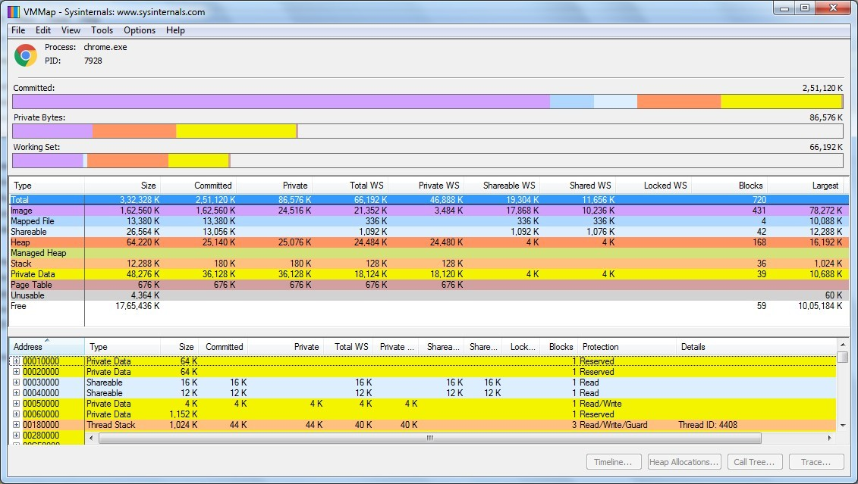

1. **Monitor Cache Memory (Tool: RAMMap)**

**TO DO :**

* 1. Save to .RMP file.

**Output:**

